Name: **Ajay Kumar Sah**

Symbol no: 76214001

Subject: Digital Logics

Submitted To: Biraj Subedi

**Sukuna Multile Campus**

1. Seven Segment Display

Seven segment displays are the output display device that provides a way to display information in the form of image or text or decimal numbers which is an alternative to the more complex dot matrix displays. It is widely used in digital clocks, basic calculators, electronic meters, and other electronic devices that display numerical information. It consists of seven segments of light emitting diodes (LEDs) which is assembled like numerical.

Truth table

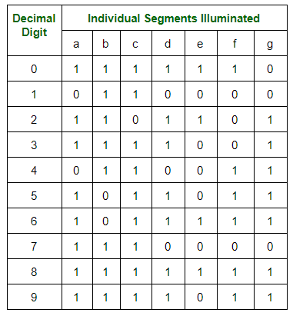

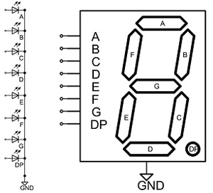

2. Parallel Adder

A single full adder performs an addition of two one bit numbers and input carry. But a parallel adder is a digital circuit that is greater than one bit in length by operating on corresponding pairs of bits in parallel. It consists of full adder connected in a chain where the output carry form each full adder is connected the carry input of the next high order full adder in chain.

A n bit parallel adder require an full adder to perform two operation. So for two bit number, two adders are needed while for four bits number four adders are needed and so on parallel adder normally incorporated carry in corporate carry look a made logic to ensure that carry propagation between subsequence stages of addition does not limited addition speed.

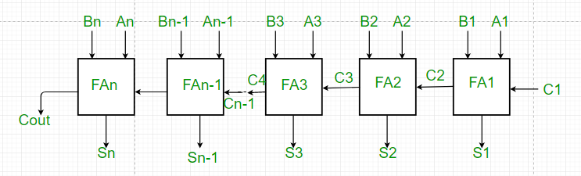

1. From the above figure the first adder fA1 adds the inputs bits a1 and b1 to produce sum s1 and carry c2 which is connected to the next full adder in chain.
2. Similarly next full adder also uses the carry bit c2 from the first adder to add with the input bits a2 and b2 to generate sum s2 and carry c3 which is connected to the next full adder and so on.
3. This process is continue till last full adder FAn uses the carry bit cn to add with input bit an and Bn to generate n output sum Sn with carry Cout.

3. Application of Register

A Register is a circuit consisting of Flip-Flops which can store more than one-bit data. The register is nothing but a sequential logic circuit in digital electronics. Before going to know about you must know about the Flip-Flop. So first read about the basics of Flip-Flop.  
  
We know that there are two types of circuits in digital electronics one is Combinational logic circuit and other is [Sequential logic circuit](https://www.elprocus.com/tutorial-on-sequential-logic-circuits/). We know that Flip-Flop is a [Combinational Logic Circuit](https://www.electronics-tutorials.ws/combination/comb_1.html).  
  
To store the data in digital form, the concepts of Flip-Flop came. We also know that a Flip-Flop can only store one-bit data. So if we want to store more than one-bit data then what to do? This problem is overcome by making Register.  
So Register is nothing but a group of Flip-flops which can store more than one-bit data. In digital electronics Logic Gates, flip-flops, registers are very important and interesting topics because they are the basic components of Microprocessor, CPU, and Memory etc.

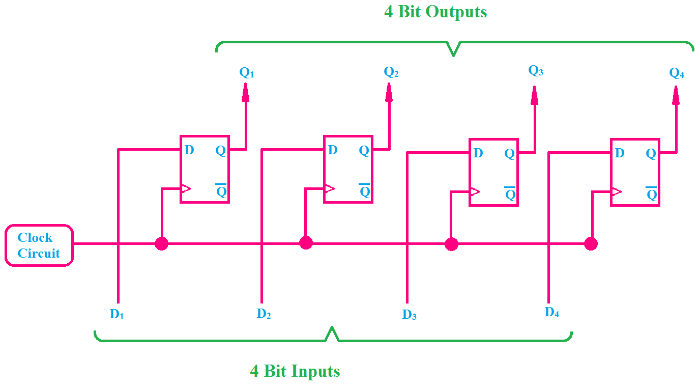

Here D Flip-flops are used. You can also see that the clock terminal of each flip-flop is connected together because we give the clock pulse to all flip-flops together. Always remember that in the case of the register or any memory circuit using flip-flops, the [clock pulse](https://www.computerhope.com/jargon/c/clockpul.htm) is always given together to all the flip-flops.

4. VHDL

VHDL is a description language for digital electronic circuits that is used in different levels of abstraction. The VHDL acronym stands for VHSIC (Very High Speed Integrated Circuits) Hardware Description Language. This means that VHDL can be used to accelerate the design process. It is very important to point out that VHDL is NOT a programming language. Therefore, knowing its syntax does not necessarily mean being able to designing digital circuits with it. VHDL is an HDL (Hardware Description Language), which allows describing both asynchronous and synchronous circuits.

VHDL (VHSIC Hardware Description Language) is a hardware description language used in electronic design automation to describe digital and mixed-signal systems such as field-programmable gate arrays and integrated circuits.

In VHDL an entity is used to describe a hardware module. An entity can be described using,

* Entity declaration
* Architecture
* Configuration
* Package declaration
* Package body

AND Gate Code:

library ieee;  
  
use ieee.std_logic_1164.all;  
  
entity and_gate is  
  
port (a,b : in std_logic ;  
  
c : out std_logic);  
  
end and_gate;  
  
architecture arc of and_gate is  
  
begin  
  
c <= a and b; end arc;

5. Multiplexer and De-multiplexer

A. Multiplexer

Multiplexer is a combinational circuit which selected single information from multiple inputs one at a time with help of selection line. Multiplexing is the process of transmitting a large number of information over a single line for ‘n’ inputs therefore ‘m’ selection line and a single output where $2^{m}$ =1.

* Multiplexers are used in data routing application to rout the data in sequence and particular directions well as destination as a single output from several input signals.
* It is used as logic function generator where logical expression (Boolean algebraic functions) can be generated instead of logic gates.
* MUX can be also used to convert the parallel data in serial data. Parallel to serial conversion is needed in measurement. Testing, military, aerospace data communication and telecommunication.

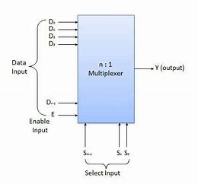

B. De-Multiplexer

A de-multiplexer is a circuit that receives information on a single line and transmits this information on one of $2^{n}$ possible output lines. The selection of a specific output line is controlled by the bit values of n selection lines.

De-multiplexing basically means, when speaking of video formats, splitting the file that contains both audio and video data (and possible other data streams as well, like subtitles), into separate files, each containing one element of the original file.

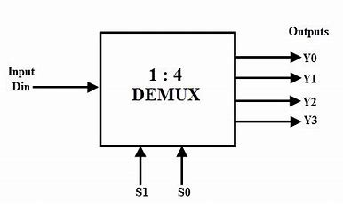

6. Digital and Analog Devices

A. Digital System

Digital system process digital signals which can take only a limited number of values, usually just two values are used: the positive supply voltage (+vs) and zero volts (0v). A digital meter can display many values, but not every value within its range. Digital system has square waves to present its data.

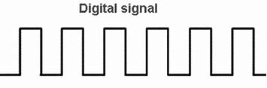

B. Analog System

Analog systems process analog signals which can take any value with a range for example the output from a speaker or a microphone. An analog meter can display any value within the range available on its scale. However, the precision of reading is limited by our ability to read them. Analog system has sine waves to present its data.

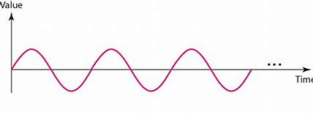

7. Electronic Gates

Electronic gates are digital circuits that operate on one or more input signals to produce an output signal. Electrical signals or voltages exist throughout a digital system in either one of two recognizable values (bi-state 0 or 1).

Electronic gates are also known as digital circuits, switching circuits, logic circuits and gates. Gates are the basic building block of any digital system. In the electronic gates, the relationship between the input and output is based on certain logic. The voltage operated circuits respond to two separate voltages ranges that represents a binary variable equal to logic 1 or logic 0.

The graphic symbol used to design the three types of gates AND, OR, NOT gates and so on.

There are three types of gates in the digital electrical circuits which are shown below:

1. Basic gates: Basic gates are fundamental gates in digital circuits that can be constructed by only three gates. The basic gates are called the AND, OR, NOT gate. These gates form the basis for other gates.
2. Universal gates: A universal gates can implement any Boolean function without used any other type gate. The NAND and NOR gates are the universal gates.
3. Exclusive gates: Exclusive gates contain the XOR (EXOR) and X-NOR gates. The XOR gate is a circuit which will give a high output if either, but not both of its two inputs are high.

The following figure can systematically describe the gate system.

Basic gates

i)AND Gate

A circuit which performs an AND operation is shown in figure. It has n input (n >= 2) and one output.

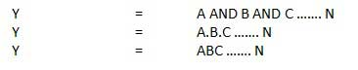

Logic diagram

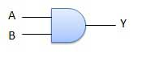

Truth Table

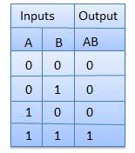

ii)OR Gate

A circuit which performs an OR operation is shown in figure. It has n input (n >= 2) and one output.

OR gate

Logic diagram

OR Logical Diagram

Truth Table

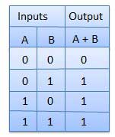

iii)NOT Gate

NOT gate is also known as Inverter. It has one input A and one output Y.

NOT gate

Logic diagram

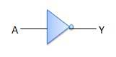

Truth table

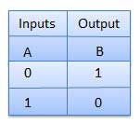

Universal Gates

i)NAND Gate

A NOT-AND operation is known as NAND operation. It has n input (n >= 2) and one output.

NAND gate

Logic diagram

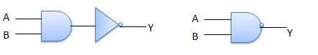

Truth Table

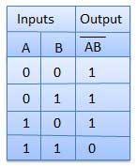

ii)NOR Gate

A NOT-OR operation is known as NOR operation. It has n input (n >= 2) and one output.

NOR gate

Logic diagram

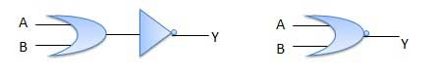

Truth Table

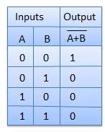

Exclusive gates

i) XOR Gate

XOR or Ex-OR gate is a special type of gate. It can be used in the half adder, full adder and subtractor. The exclusive-OR gate is abbreviated as EX-OR gate or sometime as X-OR gate. It has n input (n >= 2) and one output.

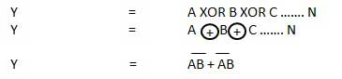

Logic diagram

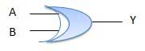

Truth Table

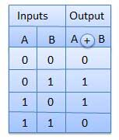

## ii) XNOR Gate

XNOR gate is a special type of gate. It can be used in the half adder, full adder and subtractor. The exclusive-NOR gate is abbreviated as EX-NOR gate or sometime as X-NOR gate. It has n input (n >= 2) and one output.

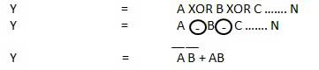

Logic diagram

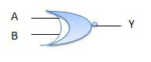

Truth Table

